Meeting Agenda
3rd Transnational Partner Meeting

Lisbon, 11th – 12th November 2021

10th November 2021 Arrival day participants

11th November 2021 TPM DAY 1

9:45 - 10:00 Welcome & Registration
CCISP, Portugal

10:00 - 10:10 IO2: Recapitulation IO2 activities & progress
KIC, Malta
10:10 - 10:30 O2A4-6: Presentation Module 1 Strategic Partnership
CASPHE, Czech republic
10:30 - 10:50 O2A4-6: Q&A
10:50 - 11:10 O2A4-6: Presentation Module 2 Purposes of QA.
CASPHE, Czech republic
11:10 – 11:30 O2A4-6: Q&A
11:30 – 11:40 Break
11:40 -12:00 O2A4-6: Presentation Module 3 Creating a Quality Culture
KIC, Malta
12:00 – 12:20 O2A4-6: Q&A
12:20 - 12:40 O2A4-6: Presentation Module 4 Setting QA Objectives
CCISP, Portugal
12:40 - 13:00 O2A4-6: Q&A
13:00 - 14:00 Lunch Break
14:00-14:20 O2A4-6: Presentation Module 5 Monitoring QA
ITS, Malta

14:20 – 14:40 O2A4-6: Q&A
14:40- 15:00 O2A4-6: Presentation Module 6 Acting on Feedback
ITS, Malta
15:00 – 15:20 O2A4-6: Q&A
15:20 - 15:40 O2A4-6: Presentation Module 7 Rewarding Quality
Skupnost VŠS, Slovenia
15:40 – 16:00 O2A4-6: Q&A
16:00 - 16:20 O2A4-6: Presentation Module 8 Specific Techniques
KIC, Malta
16:20 - 16:40 O2A4-6: Q&A
16:40 – 17:00 Recap results Day 1 & confirmation agenda Day 2

12th November 2021 TPM DAY 2

9:45 - 10:00 Welcome & Registration
CCISP, Portugal
10:00 – 10:15 Overview of IO3 Activities according to project application
KIC, Malta
10:15 – 11:15 IO3: Discussion & Guidance on creating Video content
IJS, Slovenia
11:15 – 11:30 Break
11:30 – 12:00 IO4: Introduction & planning activities IO4
Skupnost VSŠ
12:00 - 12:30 IO4A1: Identification of Model forms to be developed
Skupnost VSŠ
12:30 – 13:30 Lunch Break
13:30 -14:00 Dissemination & Impact
KIC, Malta
14:00 – 14:30 Finance & Administrative Issues
ITS, Malta
14:30 – 15:00 Recap results Day 2 & Planning next steps

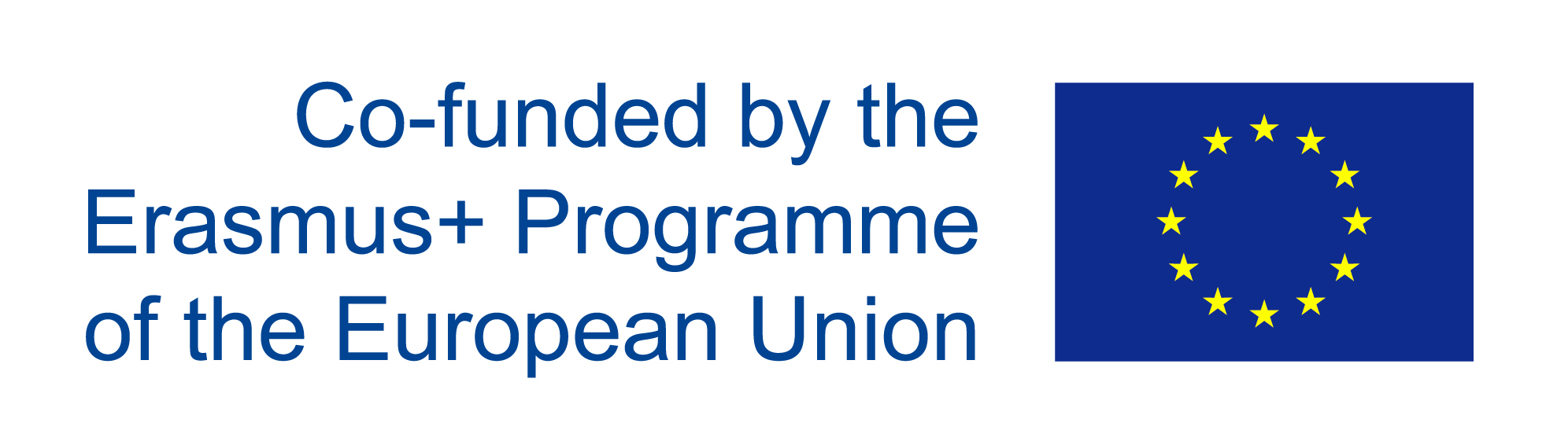
www.qalead.eu

