Meeting Agenda
4th Transnational Partner Meeting

Ljubljana, 2nd – 4th February 2022

Venue Institut “Jožef Stefan” (IJS), Jamova cesta 39, Ljubljana

See the location of IJS on the map below providing the way from the main Railway and Bus station, passing the nearby City Hotel and the city centre towards IJS.
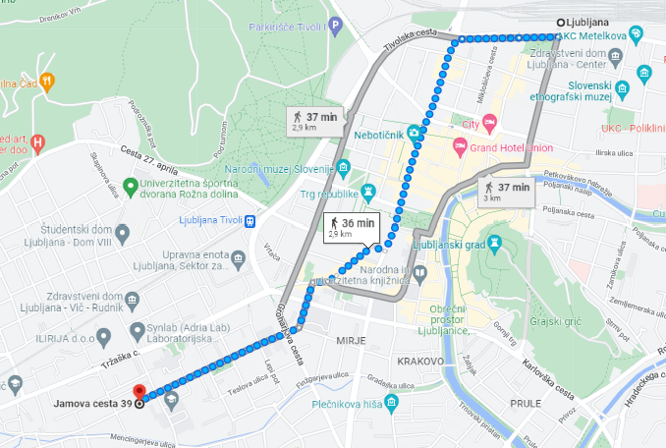

See below the main entrance to IJS, where the meeting and recording venues are.
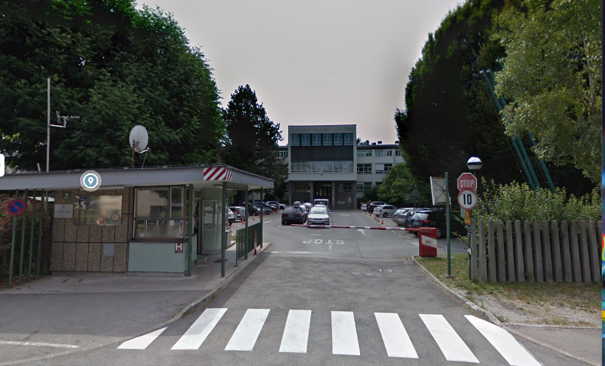

Participants on site Matija Ovsenek (IJS), George Schiavone (ITS), Jan Beseda (CASPHE), Lenka Picek Vašková (CASPHE), Nik Heerens (KIC), Larissa ??? (KIC), Armando Pires (CCISP), José Miguel Nunes Pereira (CCISP), Miha Zimšek (Skupnost VSŠ), Alicia Leonor Sauli Miklavčič (Skupnost VSŠ)

Participants online Mariah Debono (ITS), Marta Rodrigues (EURASHE)

2nd February 2022 Wednesday, TPM DAY 1 (O3A4-5 Confirming Video Scripts)

12:00 - 13:00 Welcome Lunch
IJS and partners

13:00 - 14:00 O3A5 Getting to Know the Venue (meeting room, studio)
IJS and partners

14:00 - 17:00 O3A1-4 Reviewing and Confirming the Scenarios
KIC and partners

19:00 Partner Dinner
IJS and partners

3rd February 2022 Thursday, TPM DAY 2 (O3A5 Recording)

9:00 - 9:45 Module 1, Video 1/2
IJS and CASPHE

9:45 - 10:30 Module 1, Video 2/2
IJS and CASPHE

10:30 - 11:15 Module 4, Video 1/4
IJS and CCISP

11:15 - 12:00 Module 4, Video 2/4
IJS and CCISP

12:00 - 12:45 Module 6, Video 1/1(2)
IJS and ITS

12:45 - 14:00 Lunch Break
IJS and partners

14:00-14:45 Module 8, Video 1/2
IJS and KIC

14:45- 15:30 Module 8, Video 2/2
IJS and KIC

15:30- 16:15 Module 2, Video 1/1
IJS and CASPHE

16:15- 17:00 Module 5, Video 1/2
IJS and ITS

17:00- 17:45 Module 5, Video 2/2
IJS and ITS

4th February 2022 Friday, TPM DAY 3 (Project Management, O3-4 Next Steps, O3A5 Recording)

9:00 - 10:00 Project Management
ITS

10:00- 11:00 Dissemination
ITS

11:00 - 12:00 Setting the QA-Lead Course Timeline
KIC

12:30 - 13:00 Implementation of Institutional Strategies (Next steps)
Skupnost VSŠ

13:00 - 14:00 Lunch Break
IJS and partners

14:00-14:45 Module 3, Video 1/1
IJS and KIC

14:45- 15:30 Module 4, Video 3/4
IJS and CCISP

15:30- 16:15 Module 4, Video 4/4
IJS and CCISP

Prepared by:
Alicia Leonor Sauli Miklavčič
Skupnost VSŠ

