Meeting Agenda
3rd Partner Meeting - Portugal
11th – 12th November 2021

10th November Arrival

11th November: The main objective of this day is to overview the excel sheet and
go through the 8 modules. Each module will be allocated 30 minutes for delivery of objectives, preparation and evaluation.

10:00am – 11:00am Overall Overview of excel sheet etc.

11:00am-11:30am Module 1 Strategic Partnership

11:30am-12:00pm Module 2 Purposes of QA.

12:00pm-12:30pm Module 3 Creating a Quality Culture

12:30pm – 13:00pm Module 4 Setting QA Objectives

13:00pm-14:00pm Lunch Break

14:00pm-14:30pm Module 5 Monitoring QA

14:30- 15:00pm Module 6 Acting on Feedback

15:00pm-15:30pm Module 7 Rewarding Quality

15:30pm -16:00pm Module 8 Specific Techniques

16:30pm-17:00pm Creating the Introduction Video content

12th November 2021:

10am-13:00pm Activities related to output 4

13:00pm-14:00pm Lunch Break

14:00pm-15:00pm Dissemination and Administrative Issues

13th November Departure

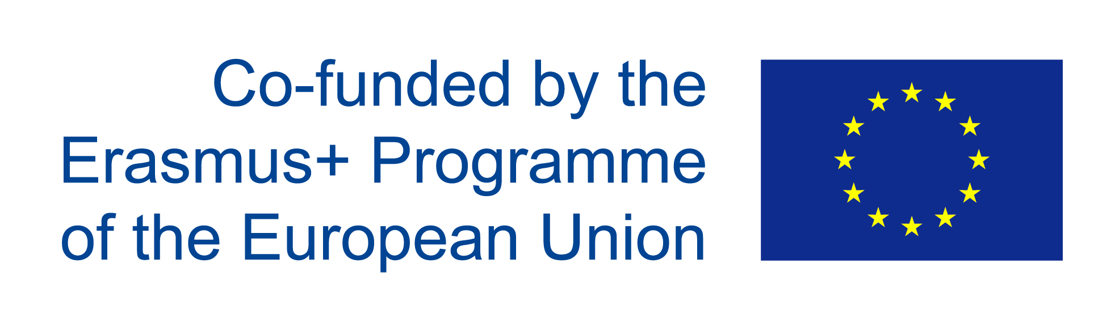
www.qalead.eu

