**Meeting Agenda**

**5th Partner Meeting – Czech Republic**

**12-13 June 2022**

**30 minutes Training event**

Evaluation of the training

* During training
* After training

**45 minutes Online Course**

* 1. - Videos
     + 1. - Planning finalisation online course
       2. - Link of online course to training
       3. - Validation of online course
       4. - Translation in partner languages

**20 minutes Intellectual Output 4**

- Planning/timeline

* + - 1. - Task division update

**15 minutes Dissemination**

* + - 1. - Opportunities for dissemination project outputs
      2. - Google adds?

**20 minutes Finances**

- Budgetary changes to cover training

* + - 1. - Update of staff days (ITS—> KIC transfer)

**20 minutes Communications**

- Dropbox issues/limitations

* + - 1. - Planning online meetings for remainder of the project

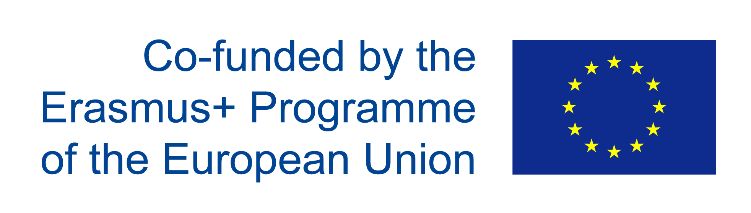

www.qalead.eu